# Cloud front & Route 53.

1. **Configure VPC peering in cross regions.**

* Go to ec2 console.
* Open a search bar and press **VPC.**
* Create 2 vpc with “**Different Region” Ex:** one in eu-stokholm and one is N.Verginia.
* This 2 vpc in **CIDR**  range should be different. One in class **A** range and other one is class **C** range.
* Class A should be **10.0.0.16/24**
* Class C Should be **192.168.0.0./24**
* Then go cross peering option.
* Then select one vpc for request and other one is acceptance.
* **HERE THE RESULTS ARE:**

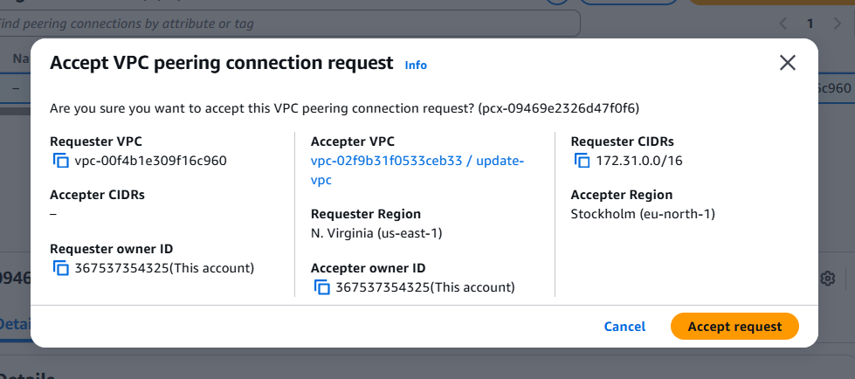

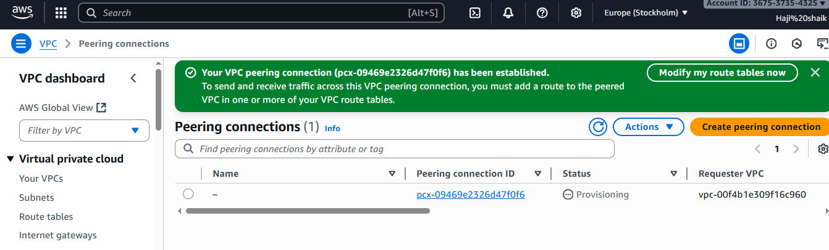

1. **Purchase one domain from GoDaddy.**

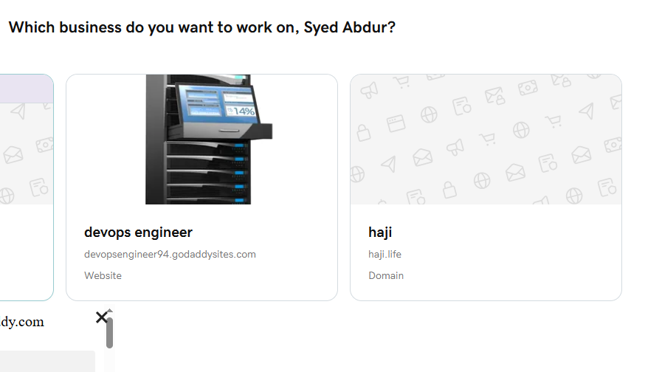

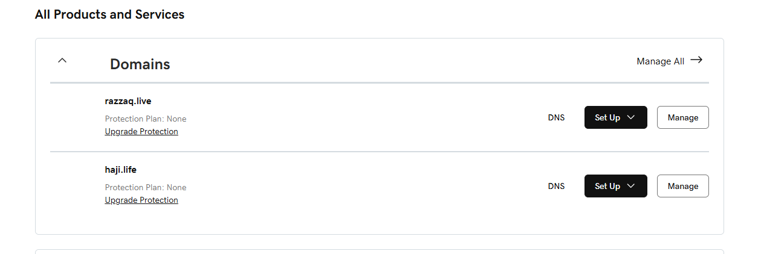

1. **Deploy static website in S3.**

* go to the aws console.
* Then search bar in s3.
* Then create bucket.
* Go to the permissons then create a 2 files .html files.
* Then upload the files.then gave a prmsn to public.

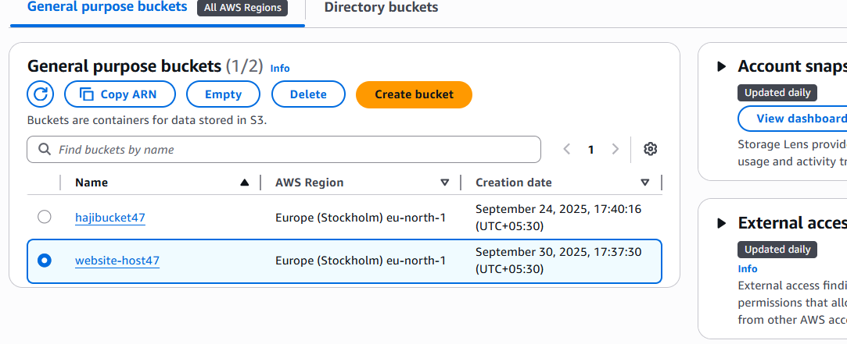

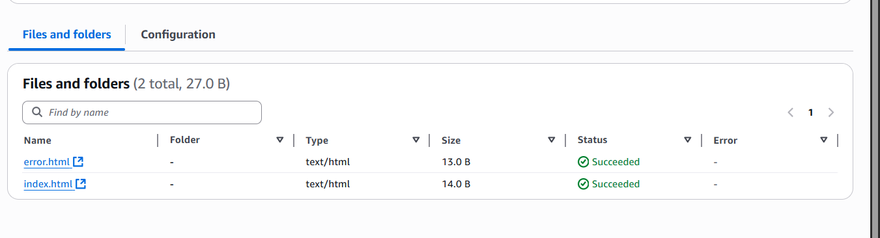

**Enable the static website host:**

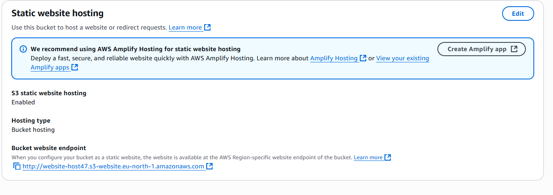

**Make 2 files convert in to public:**

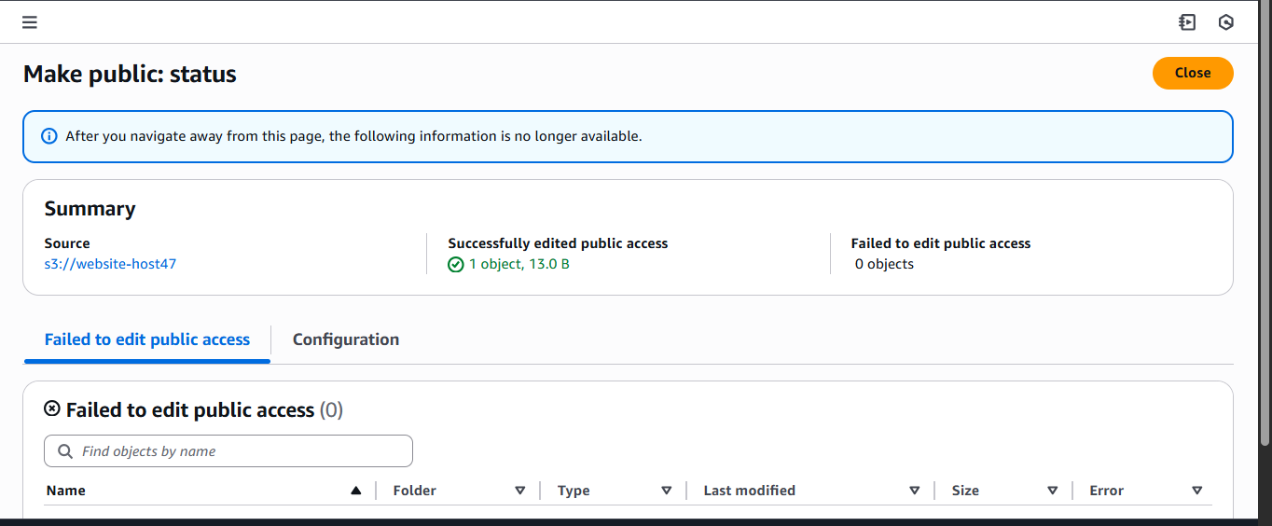

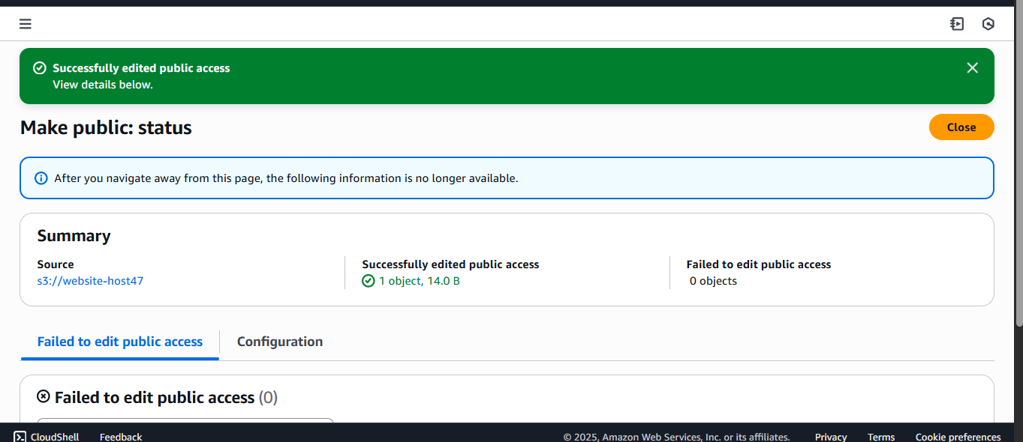

**Then copy the both links:**

**And paste in to the browser:**

**Here the results are for index.html>>>>>**

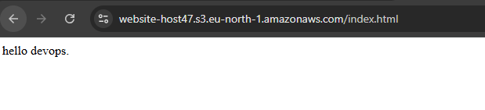

**Here the results are for error.html>>>>>**

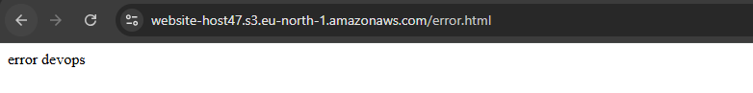

1. **Create a CDN and attach one SSL certificate.**

* **Go** to aws console.
* Then go to the **ACM MANAGED CERTIFICATE.**

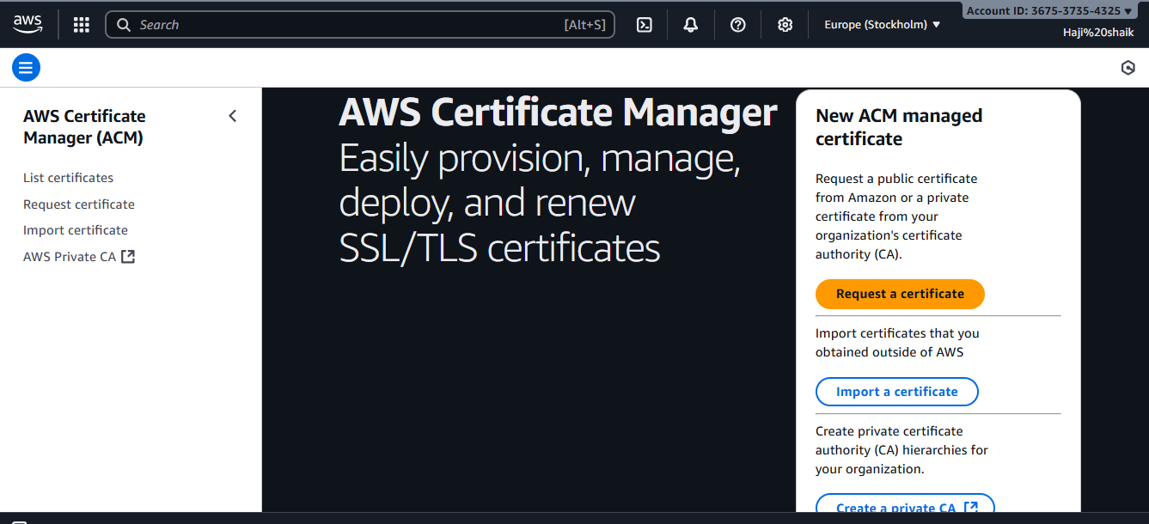

* Then a request a certificate specially on region in **us-east-1**

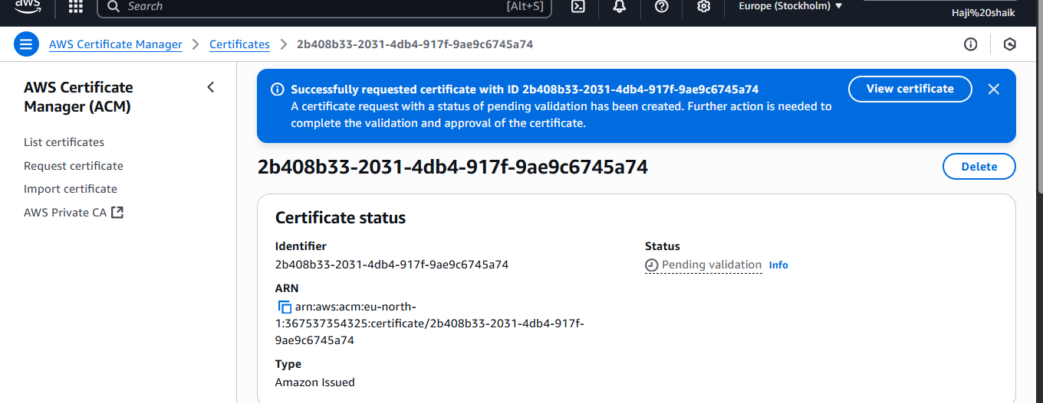

* Then a wait for a issued will appear.

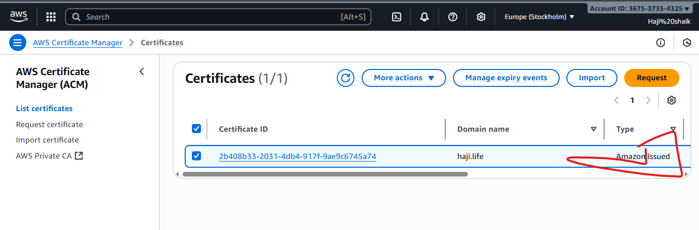

* Then **go the CLOUD FRONT.**
* **Then create a cloud front disturubation.**

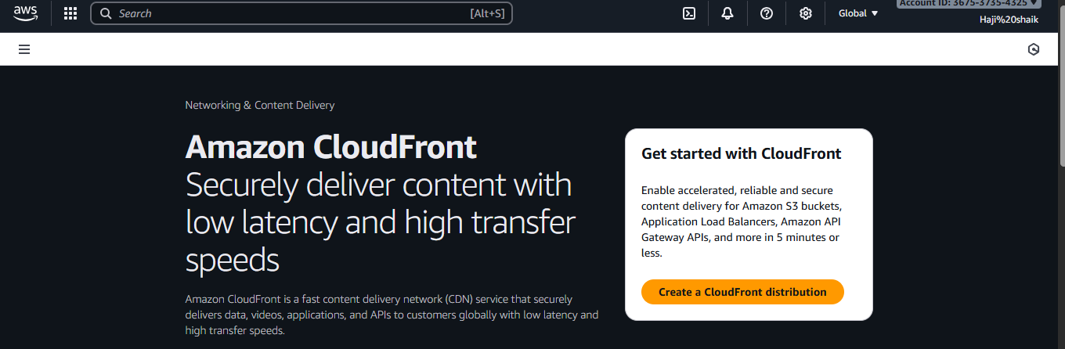

* Gave a name any thing then go to the defult settings.
* And check your domain name.
* And paste the browse s3 website then go to the next page.

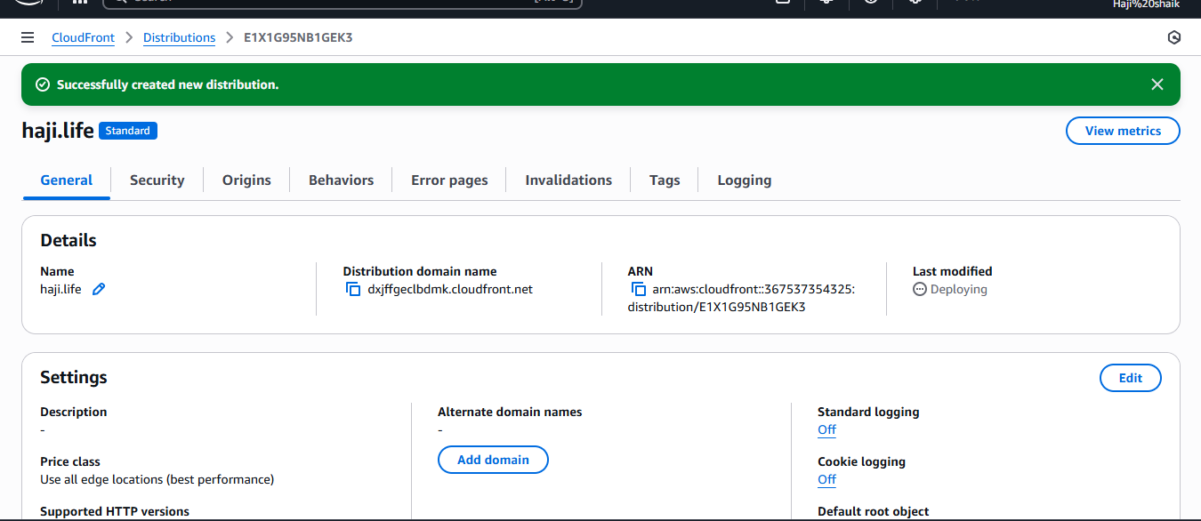

* Then check record in cloud front.
* If its not created create a one record. In cloud front.
* Make sure your s3 bucket also same name as your doamin name.
* Then upload two files which is index.html error.html.
* make sure it should be on public.
* then copy the url from bucket properties.

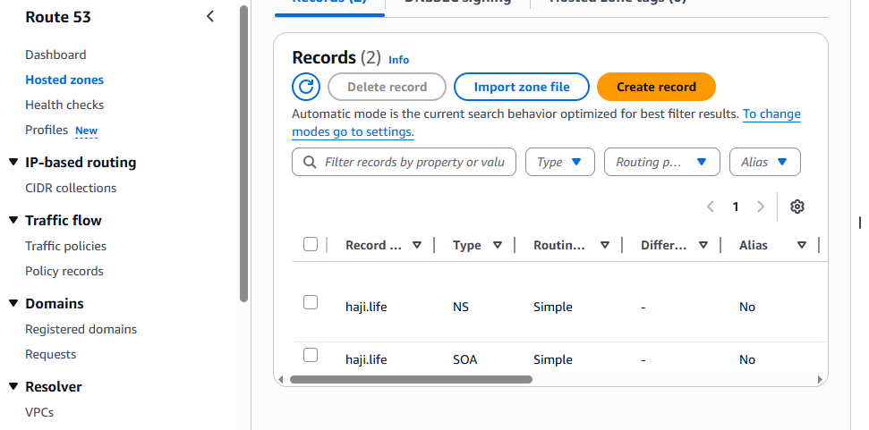

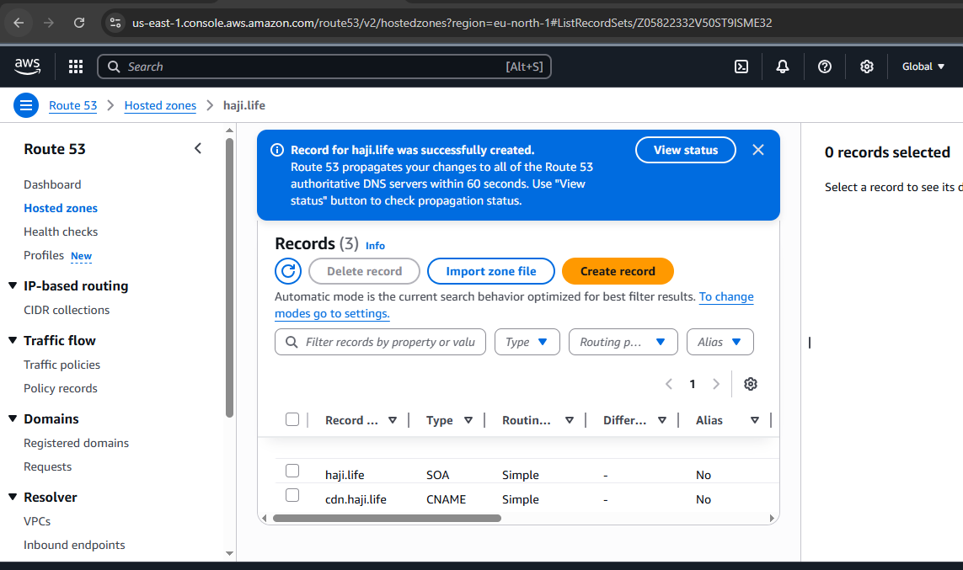

* Then check for its issued.
* Then copy of the link in cloudfront url.
* And paste it.
* **Here the results are:**

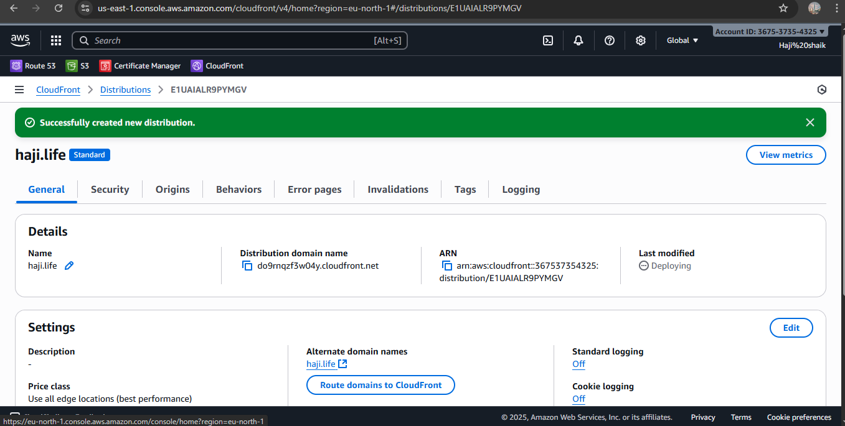

* **Here the results are:**

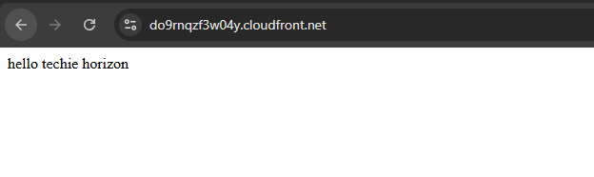

1. **Create a Route 53 hosted zone and map the domain with the CDN.**

* Go to the aws console.
* Then go to the route 53 nd creating record.
* And it will gave uh a four websites and go to the go daddy website.
* Where you purchase go daddy.
* Open a website and edit DNS name servers.
* Copy the four DNS websites.
* ns-1640.awsdns-13.co.uk  
  ns-456.awsdns-57.com  
  ns-936.awsdns-53.net  
  ns-1311.awsdns-35.org

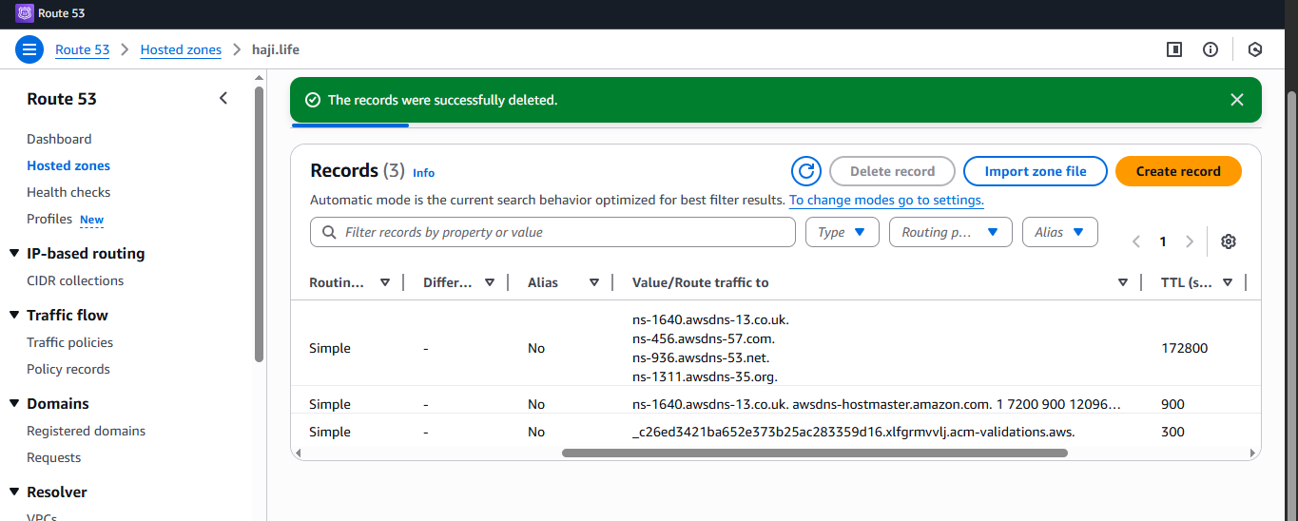

* Server names in Godaddy.

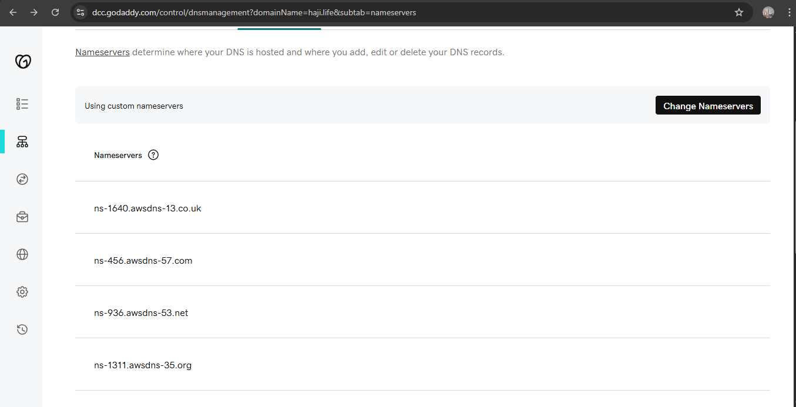

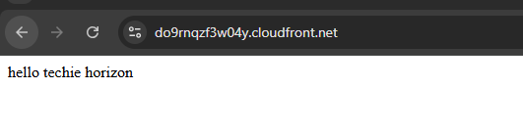

1. **Update the index.html in the S3 bucket and ensure the updated file is accessible using the domain name.**

* **Go to the cloud front distribution.**
* **And copy the distribution domain name.**
* **And paste it in the browser.**

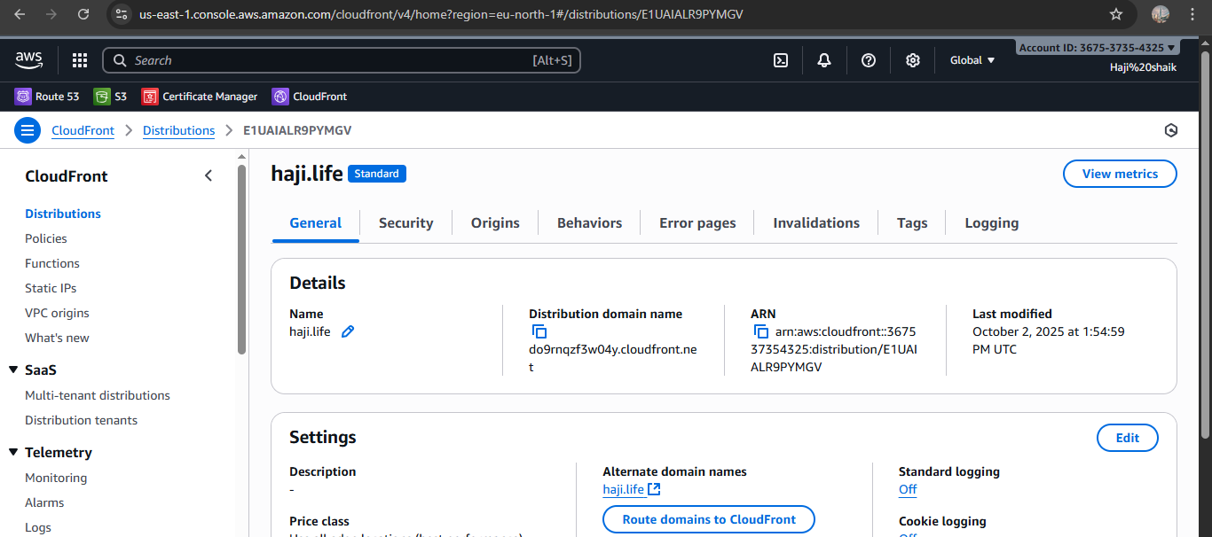

* **And paste it.**



1. **Share the domain name in Slack to test the connectivity.**

**https://haji.life/**